* Parameter
  + path, name, value

which URL the method is mapped to

* + method

compatible HTTP methods

* + params

filters requests based on presence, absence, or value of HTTP parameters

* + headers

filters requests based on presence, absence, or value of HTTP headers

* + consumes

which media types the method can consume in the HTTP request body

* + produces

which media types the method can produce in the HTTP response body

* **Request Path**

VD1: single path

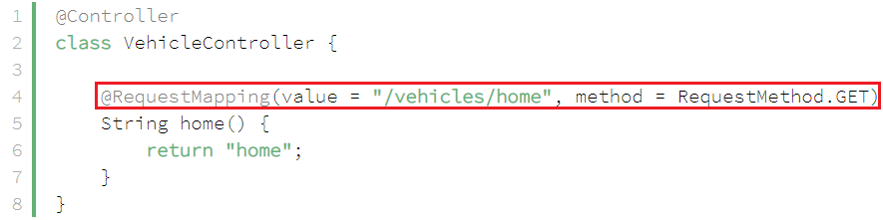

*Tương đương (URL = "http://localhost:8080/vehicles/home"*

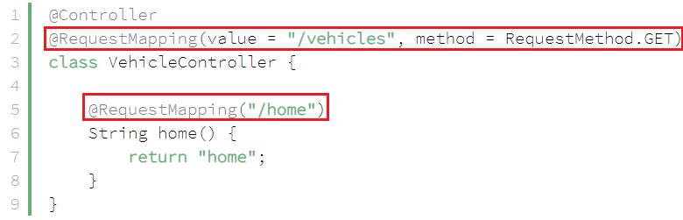

VD2: multiple path

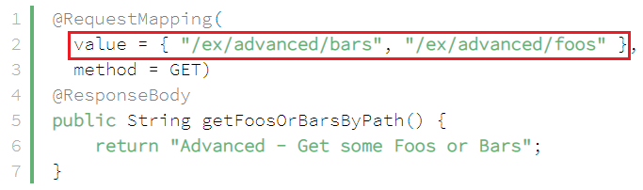

* **Request Method**

Cách viết khác tương đương với @GetMapping, @PostMapping, @PutMapping, @DeleteMapping



*Tương đương*



[*https://www.baeldung.com/spring-new-requestmapping-shortcuts*](https://www.baeldung.com/spring-new-requestmapping-shortcuts)

VD1: multiple method

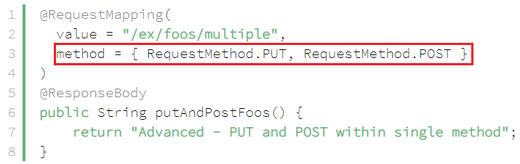

VD2: a Fallback for All Requests

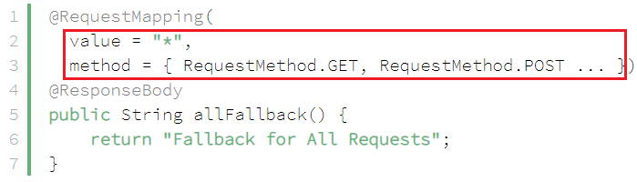

* **HTTP Headers**

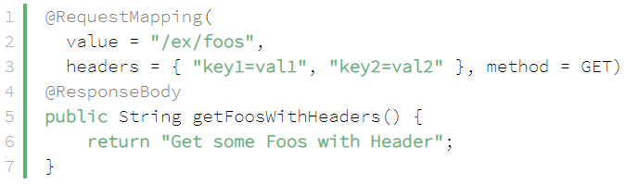

VD1:

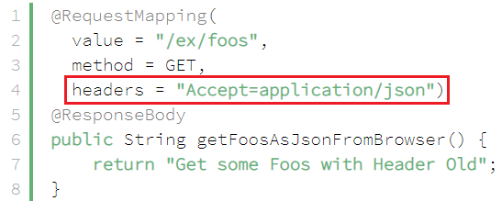 hoặc 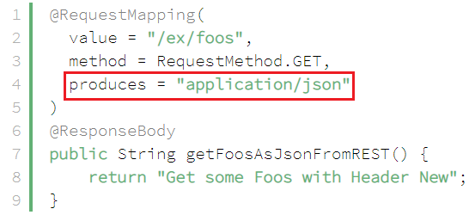

* **@PathVariable**

VD1: single variable

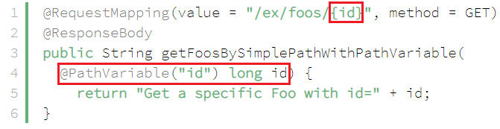

*http://localhost:8080/ex/foos/1*

VD2: multiple variable

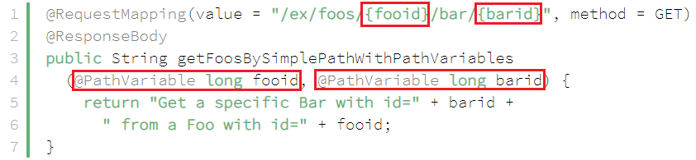

*http://localhost:8080/ex/foos/1/bar/2*

VD3: Regex

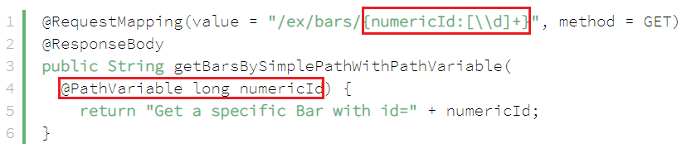

*http://localhost:8080/ex/bars/1*

VD4: required = false

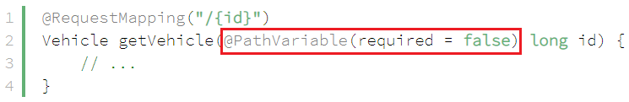

* **Request Parameters**

Thay thế cho **HttpServletRequest.getAttribute(String nameAttribute)**

VD1:

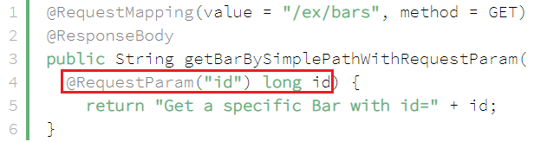

*http://localhost:8080/ex/bars?id=1*

VD2: default value

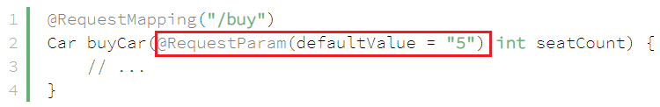

VD3: key-value mapping



VD4: object mapping



* **@RequestBody**

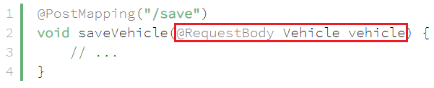

* **Reference**

<https://www.baeldung.com/spring-mvc-annotations#request-mapping>

<https://www.baeldung.com/spring-requestmapping>